  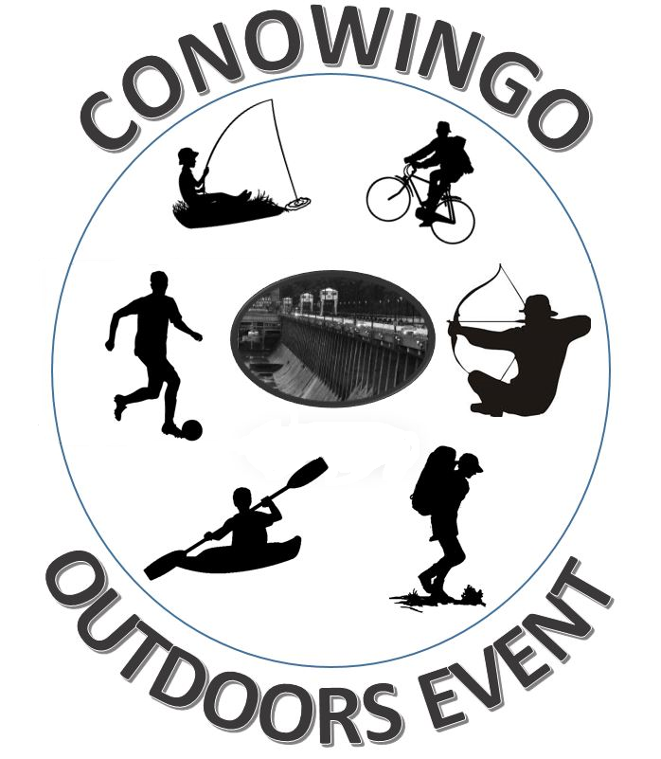
  Conowingo Park
  Rt.222 1 mile south of the Dam
  MAY 9^{TH,} 2015 NOON TILL 4PM “FREE EVENT”
  Come out and learn about recreational opp0rtunities in our area. See demonstrations, sign up for sports through Cecil County Parks and Recreation, West Cecil Athletic Assoc. Learn about boating, bird watching, and much more.
  Hunting
  Fishing
  Kayaking
  Hiking
  Biking
  Sports
  Boating
  sponsored by
  The Conowingo Lions Club
  410-920-8404
  
  Visit Us On Facebook
  https://www.facebook.com/conowingolionsclub

